**DAY-14 ASSIGNMENT**

**NAME: SUDHA SREELATHA**

**EMP ID: 46255249**

**Q1.** Create a Simple CDS view with Date Functions in ABAP CDS Views

**Tables involved** – VBAK

**CODE:**

**OUTPUT:**

Q2. Create a Simple CDS view with String Functions in ABAP CDS Views.

CODE:

**OUTPUT:**

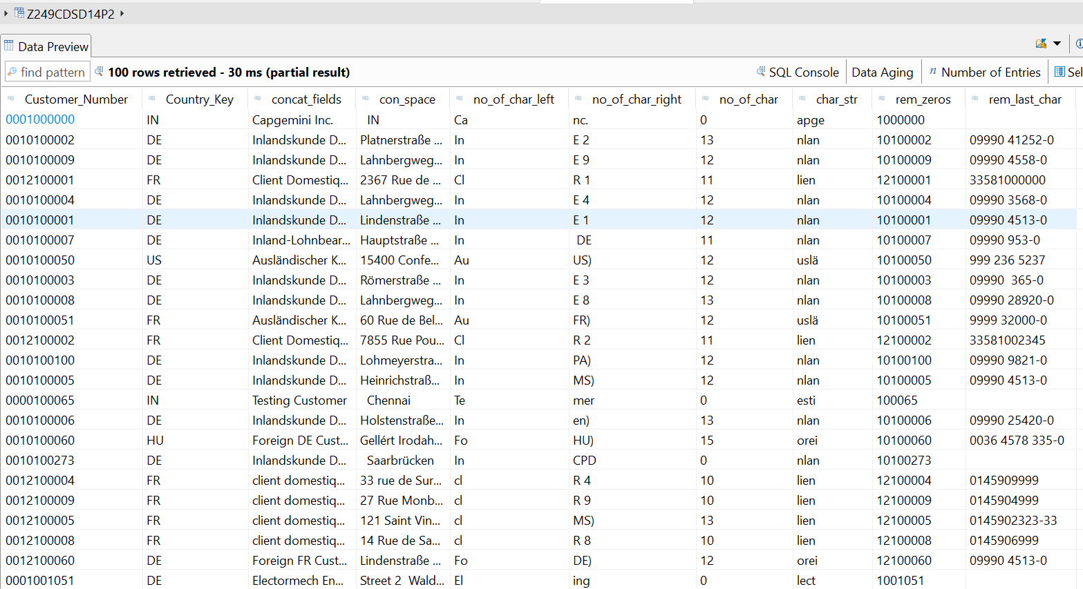

Q3. Create a Simple CDS view with Parameters

**Scenario** –

* Create a CDS view with GL currency (PSWSL) as parameter and get the entries form BSEG

**Tables involved** – BSEG

**CODE:**

**OUTPUT:**

**AMDP-Assignment 1** – Procedures - create a basic procedure to fetch data with scalar variable

**Scenario** –

* Print Sales Order number, Material Number, Quantity from VBAP table using scaler variable

**Tables involved** – VBAP

**AMDP CLASS:**

**CODE:**

**CLASS OUTPUT:**

**REPORT:**

**OUTPUT:**

AMDP-Assignment 2 – Procedures - create a basic procedure with Table

**Scenario** –

* Select VBELN, VKORG, MATNR, MENGE from VBAK and VBAP and display the data using table based on material (MATNR).
* MATNR will be input field
* Do inner join

**CODE:**

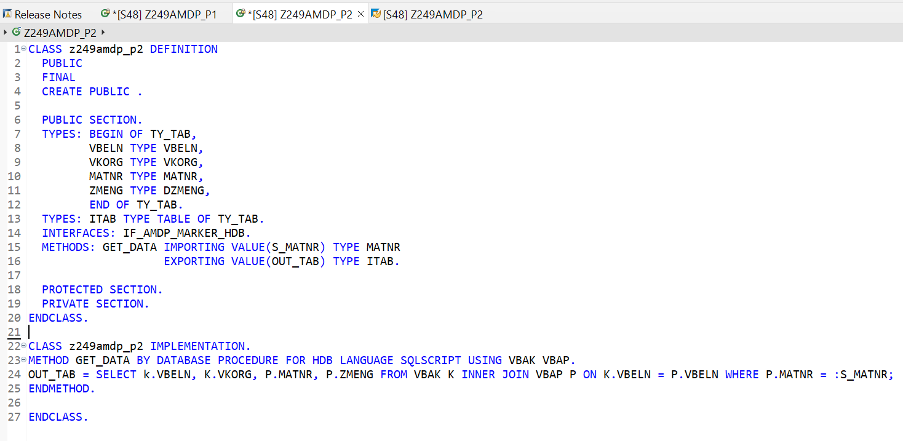

**OUTPUT:**

**REPORT:**

**OUTPUT:**

